***WEEK 1 COGNIZANT LEARNING***

***DESIGN PATTERNS AND PRINCIPLES***

Exercise 1: Implementing the Singleton Pattern

CODE –

using System;

namespace SingletonPatternExample

{

    public class Logger

    {

        private static Logger instance;

        private static readonly object lockObj = new object();

        private Logger()

        {

            Console.WriteLine("Logger initialized.");

        }

        public static Logger GetInstance()

        {

            if (instance == null)

            {

                lock (lockObj)

                {

                    if (instance == null)

                    {

                        instance = new Logger();

                    }

                }

            }

            return instance;

        }

        public void Log(string message)

        {

            Console.WriteLine("Log: " + message);

        }

    }

    class Program

    {

        static void Main(string[] args)

        {

            Logger logger1 = Logger.GetInstance();

            logger1.Log("Application started.");

            Logger logger2 = Logger.GetInstance();

            logger2.Log("Another log message.");

            Console.WriteLine($"Same instance? {ReferenceEquals(logger1, logger2)}");

        }

    }

}

*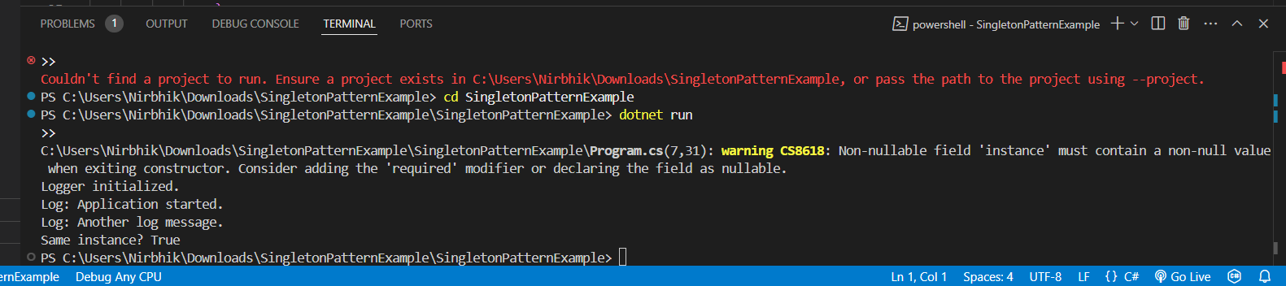OUTPUT –*

Exercise 2: Implementing the Factory Method Pattern

*CODE –*

*using System;*

*namespace FactoryMethodPattern*

*{*

*public interface IProduct*

*{*

*string GetDetails();*

*}*

*public class ConcreteProductA : IProduct*

*{*

*public string GetDetails()*

*{*

*return "This is Product A.";*

*}*

*}*

*public class ConcreteProductB : IProduct*

*{*

*public string GetDetails()*

*{*

*return "This is Product B.";*

*}*

*}*

*public abstract class Creator*

*{*

*public abstract IProduct FactoryMethod();*

*}*

*public class ConcreteCreatorA : Creator*

*{*

*public override IProduct FactoryMethod()*

*{*

*return new ConcreteProductA();*

*}*

*}*

*public class ConcreteCreatorB : Creator*

*{*

*public override IProduct FactoryMethod()*

*{*

*return new ConcreteProductB();*

*}*

*}*

*class Program*

*{*

*static void Main(string[] args)*

*{*

*Creator creatorA = new ConcreteCreatorA();*

            IProduct productA = creatorA.FactoryMethod();

            Console.WriteLine(productA.GetDetails());

            Creator creatorB = new ConcreteCreatorB();

            IProduct productB = creatorB.FactoryMethod();

            Console.WriteLine(productB.GetDetails());

        }

    }

}

*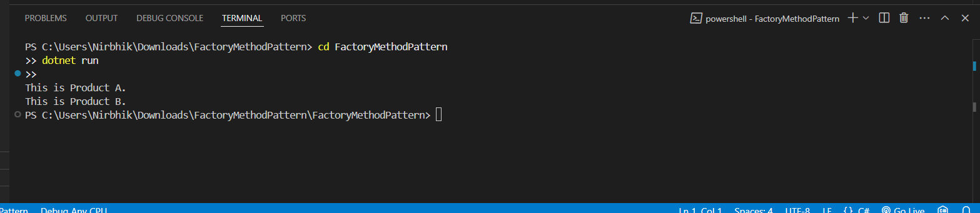OUTPUT --*